Student’s Name
Professor’s Name
Course
Date
Analysis of the 4COF and 2BYS drugs
In the Lipinski’s rules of five, therapeutics, and the action of remedial agents have always been the small molecules that are considered in this discussion. In this scenario, it is Lipinski’s rule which is a rule of thumb has been used to evaluate explains the drugability and the pharmacological activity contained in the drug molecules. Pharmacokinetic abilities of drugs such as absorption, distribution, mechanism, excretion, and metabolism of the molecular aspect of drugs are always considered to be discussed. The 4COF drug is a human gamma-amino butyric acid receptor drug that functions effectively in the body of man. The 2BYS is another receptor drug that has been made complex with the combination of lobeline in it. It is also designed to perform its functions within the body of man. This discussion will major on the therapeutics cropping from the molecular action of these drugs in line with the structure involved in the drugs. All these discussions will be put in line with consideration of the Lipinski’s rules of five.
The 4COF drug is a type A kind of aminobutyric receptor drug. They are also the main inhibitors of rapid synaptic transmission in the human brain. The lack of this receptor in the brain of the Homo sapiens species triggers neurological disorders such as anxiety, insomnia and in the worst cases, epilepsy. The structure of the 4COF gamma-aminobutyric acid receptor has elements that coincide with the eukaryotic Cys-loop receptors. The structure of the receptor was also crystallized and bound to benzamidine, as a way of rational modulation of the design of the gamma aminobutyric acid receptor. This structure always gives new insights into signaling mechanisms of the pentameric ion channels which help to improve the scientific understanding of the gamma amino-butyric acid energetic neurotransmission.
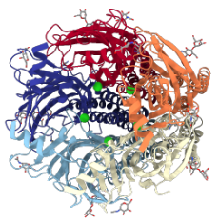
Figure 1.1: The crystal structure of the human gamma-aminobutyric acid receptor
The molecular components in the 4COF drug contain five protein molecules and 31 chemicals and non-standard bio polymers. The N-Acetyl-D-Glucosamine compound is the most dominant non-standard biopolymer present in the 31 chemical bio polymers. The chloride and benzamidine chemical molecules have the same number of proportion in the arrangements of the gamma-aminobutyric receptor structure. The Beta-D-Mannose compound is also present in the structure of the 4COF receptor drug. Subsequently, the composition of these chemical structures in the compound enable the proper functioning of the crystal structure that are involved in the domain of the cysteine-loop receptor. The combination of the chemical components also depicts a functional and structural homolog of the ligand-binding domain involved in the gamma amino-butyric receptors. The receptor drug’s crystal structure also contains several patches of hydrogen bonds that are connected with the Van der Waals contact forces. Due to the presence of the chloride ions, the main chain amino groups take the role of coordination the chloride anions across this boundary. A salt bridge network is also present in the structure to ensure the interaction of the anions and cations within the molecular components of the gamma-aminobutyric receptor structure.
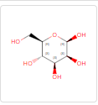
Figure 1.2: The chemical structure of the Beta-D-Mannose.
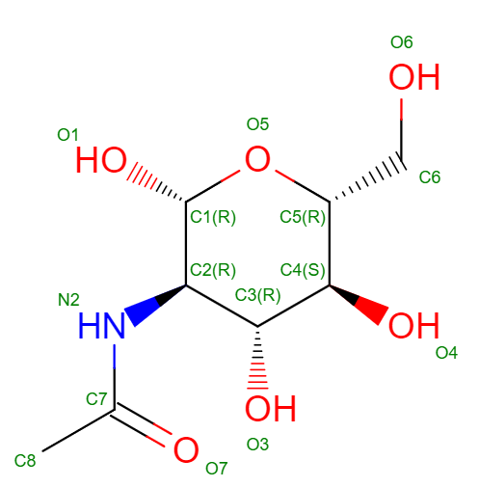
Figure 1.3: The chemical structure of the N-Acetyl-D-Glucosamine compound.
2BYS is a drug with a crystalline structure that functions to eliminate an organism known as Aplysia califonica. The drug is known for having an extracellular domain of the nicotinic acetylcholine receptor, which is fond of undergoing various conformational changes, to work on the Aplysia California organism. There are soluble ligands binding domain within the receptors that enable the acetylcholine-binding proteins in the structure of the drug to have and show disparate affinity for the nicotinic ligands. The crystal structure present in the acetylcholine-binding protein was chemically formulated from the organism Aplysia califonica. The receptive nature of the acetylcholine binding protein enables complexion with the nicotinic ligands which remains the same upon the binding of the peptidic antagonist known as methyllycaconitine. The 2BYS receptor being a well-defined nicotinic acetylcholine receptor drug, ensures the rapid gating of its ions that are propagated by the acetylcholine element. The ligand binding domain contains four intermembrane spanning regions that are responsible for the formation of the channel in which ions are produced. There are also extender intermembrane regions between the third membrane layer and the forth membrane layer. The binding of ligands always triggers several changes that are transmitted between the intermembrane spanning regions of the 2BYS receptor. With these changes triggered, there is always an interchange of the membrane potential due to the small changes that are take place in the intermembrane span regions. However, the changes in this section are at times impaired by the increase in size of the nicotinic acetylcholine receptors.
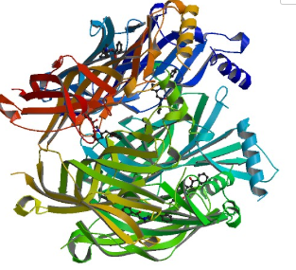
Figure 2.1: The crystalline structure of the Acetylcholine binding proteins (ACHPB) from the organism Aplysia californica.
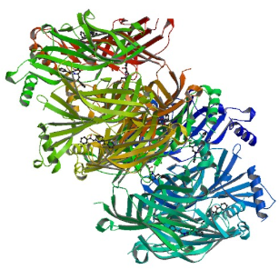
Figure 2.2: Asymmetric unit crystal structure for the ligand interaction and binding.

Acetylcholine binding proteins structure also creates a difference in the functioning of the nicotinic acetylcholine receptors. When the acetylcholine proteins assemble with identical binding sites in their various subunit interfaces, the signs of ligand specificities resembling those of the other nicotinic receptors are now visible. It is therefore correct to say that acetylcholine proteins possess a unique and specific pattern that enables them to be selective on the various types of ligands. The acetylcholine proteins do not also originate from any of the mammalian or insect biological classes. There is also a tryptophan fluorescence that is emitted by the acetylcholine proteins which is also quenched by the rapid and complex formation of the neonicotinoid. The large pentameric crystal structure of the acetylcholine proteins ensures that there is an appropriate site for the binding and destruction of the Aplysia californica organism, which is the man function of the 2BYS drug.
Generally, the 4COF drug has proved to be one of the aminobutyric receptor drugs. The 2BYS drug on the other hand is responsible for the elimination of then Aplysia californica organism from the body. The 4COF drug ensures abundant receptors in the brain so that there can be minimal cases of anxiety, insomnia or epilepsy which may be hazardous to the normal functioning of the human body. The 2BYS is also viewed as a nicotinic type of receptor drug which enable it to carry an ability that will ensure appropriate functioning of the body organs due to the right quantity of nicotinic substances in the body. All the two drugs are receptor drugs which regulate the functioning of pharmacologic agonist and antagonist actions in the body.

Works Cited
Hansen SB , et al. "Structures of Aplysia AChBP Complexes with Nicotinic Agonists and Antagonists Reveal Distinctive Binding Interfaces and Conformations. - PubMed - NCBI." National Center for Biotechnology Information, www.ncbi.nlm.nih.gov/pubmed/16193063.
Miller, Paul S., and A. Radu. "Crystal Structure of a Human GABAA Receptor." PubMed Central (PMC), Aug. 21, www.ncbi.nlm.nih.gov/pmc/articles/PMC4167603/.
Miller P. "4COF: Crystal Structure Of A Human Gamma-aminobutyric Acid Receptor, The Gaba(a)r-beta3 Homopentamer." National Center for Biotechnology Information, www.ncbi.nlm.nih.gov/Structure/pdb/4COF.
RCSB Protein Data Bank. "RCSB PDB - 4COF: Crystal Structure of a Human Gamma-aminobutyric Acid Receptor, the GABA(A)R-beta3 Homopentamer." RCSB PDB: Homepage, www.rcsb.org/structure/4COF.
Talley, Todd T., et al. "Atomic Interactions of Neonicotinoid Agonists with AChBP: Molecular Recognition of the Distinctive Electronegative Pharmacophore." PNAS, 27 May 2008, www.pnas.org/content/105/21/7606.

